Quickstart Guide – Sim App
[These instructions assume you have NEPI Engine software running on your computer and an Ethernet-enabled edge-compute hardware platform. The simulators run in Docker on your computer; the setup below installs Docker if it is not already installed.]

Run these commands from your computer
- Use your computer that is connected to a NEPI device for this quickstart guide

Clone the NEPI simulators repo
- Clone the NEPI simulators repo:
cd ~/
git clone https://github.com/nepi-engine/nepi_simulators.git


Clone the NEPI drones repo
- Clone the NEPI drones repo:
git clone https://github.com/nepi-engine/nepi_drones.git


Set up the NEPI simulators
- Run the NEPI simulators setup script; accept the license and enter your password when prompted:
./nepi_simulators/scripts/nepi_simulators_setup.sh
- When asked for the NEPI device address and the NEPI storage share user, press Enter to keep the defaults (192.168.179.103 and nepi).
- If the setup says you were just added to the docker group, log out of your computer and back in, then open a new terminal. Otherwise, run:

sbrc


Download the simulator image
- Download the NEPI simulator image (numurusinc/nepi_simulations on Docker Hub), which contains Gazebo and MuJoCo. The first download takes a while:
nepi_simulators_pull


Check connection to your NEPI device
- Check your connection to your NEPI device. Expected output: “NEPI Connected at …”:

pingn


Start Gazebo
- Start the Gazebo simulator, giving the nepi storage password (nepi); enter your password if prompted. Expected output: “The gazebo simulator is running”:

nepi_simulators_start gazebo nepi
- To use MuJoCo instead, run nepi_simulators_start mujoco nepi. One simulator runs at a time; starting one stops the other.


Deploy and build the NEPI drones repo
- Deploy the NEPI drones repo to your NEPI device; enter your password when prompted:

./nepi_drones/deploy_nepi_source.sh
- SSH into your NEPI container:

sshn
- Now you are in your NEPI container. Build the changes you deployed; enter the NEPI password when prompted:

nepibld
- Start your RUI in the NEPI container:
nepistart


Navigate to the sim app in the RUI
- Connect to the RUI in your browser at the following link: http://192.168.179.103:5003/
- Go to SYSTEM > Apps Manager. Select Sim Connector and enable it
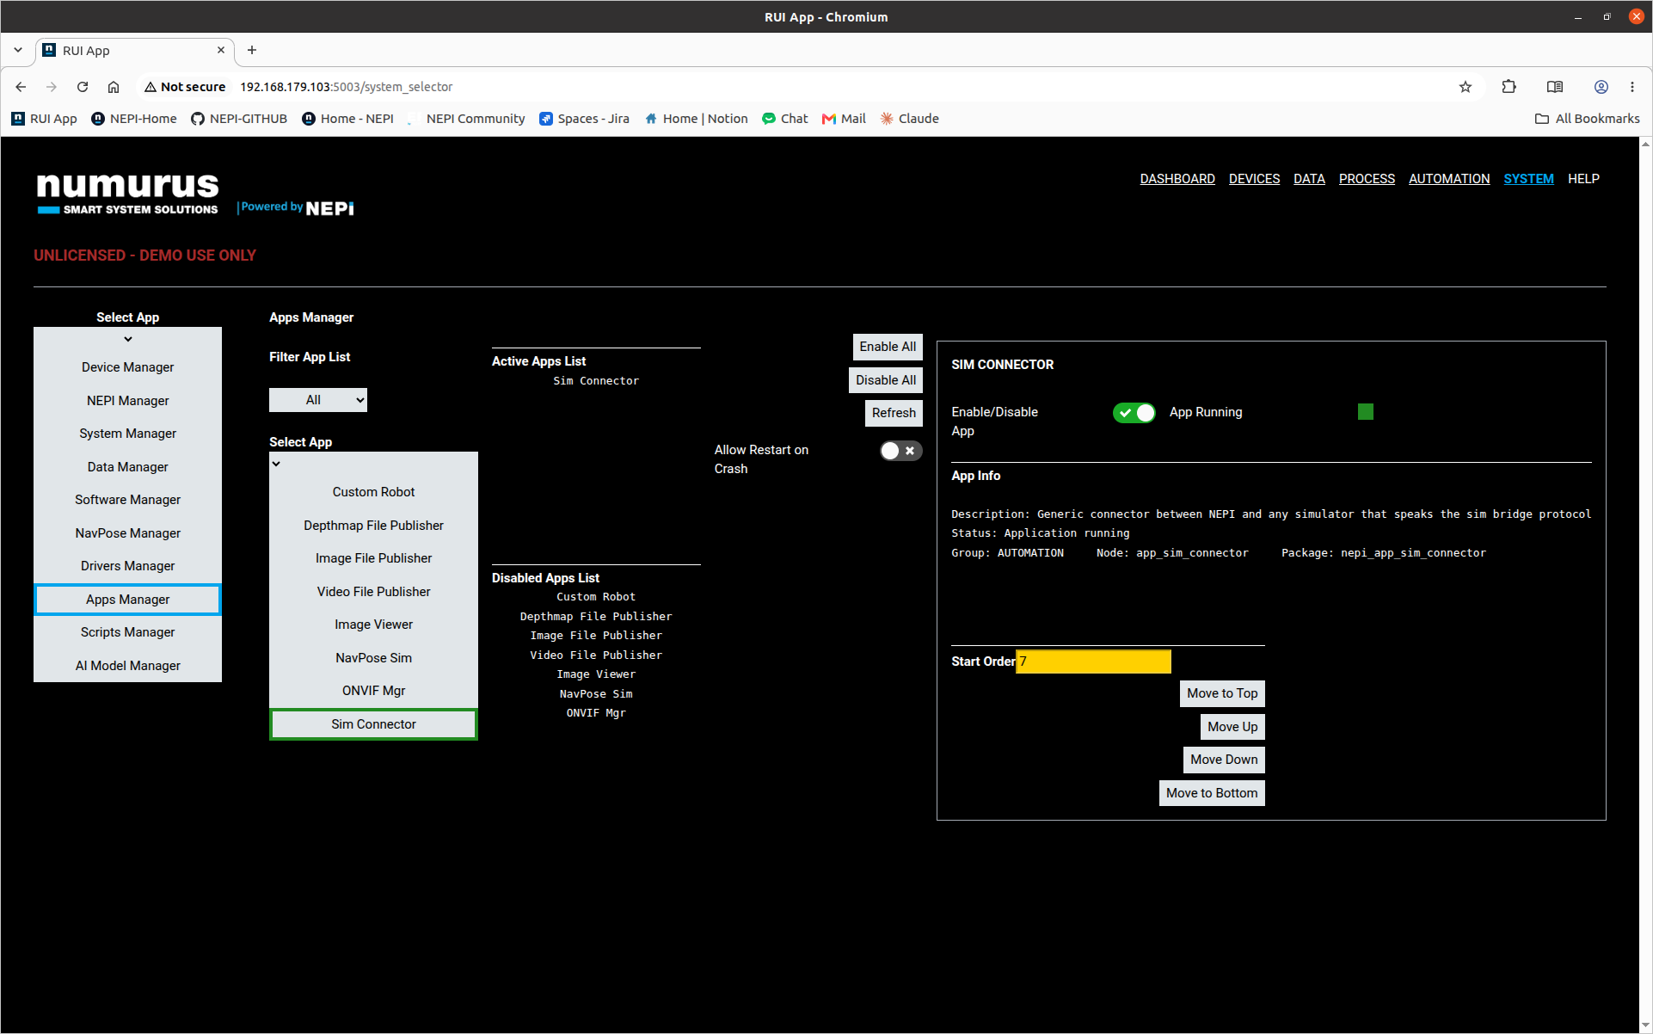

Open the sim app
- Go to AUTOMATION > Sim Connector. This is your sim app page. Below will be a camera view of the simulator that is running on your computer. Below are the relevant settings.
- Simulator: This is your active simulator; keep it selected as the one you started on your computer (Gazebo or MuJoCo).
- Robot Config: This is your robot selection. To update your simulator, use the `Use Open Sim` or `Deploy` buttons below
- Environment Config: This is your environment selection. To update your simulator, use the `Use Open Sim` or `Deploy` buttons below
- Use Open Sim: This button stops the current simulation and starts it again with your selected robot and environment configs
- Kill: This button stops the current simulation
- Deploy: This button appears when you do not have a running simulation. Pressing it will start a new simulation with your selected robot and environment configs

Open the sim rover device
- Go to DEVICES > ROBOTS and select sim_rover. This is your sim rover device page.
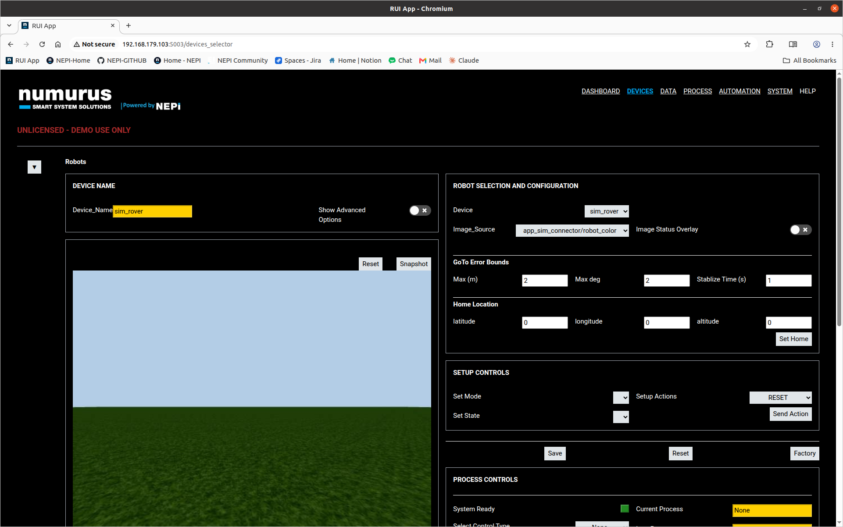
- Under PROCESS CONTROLS, set Select Control Type to Manual or Autonomous to drive the rover.


Stop the simulator
- When you are done, stop the simulator on your computer:
nepi_simulators_stop


Tutorials
The Nepi tutorials can be found at https://www.nepi.com/tutorials/

